Problem Solving 3
Areesha Raheel
55039
BSIT-6
Vertex Cover Problem
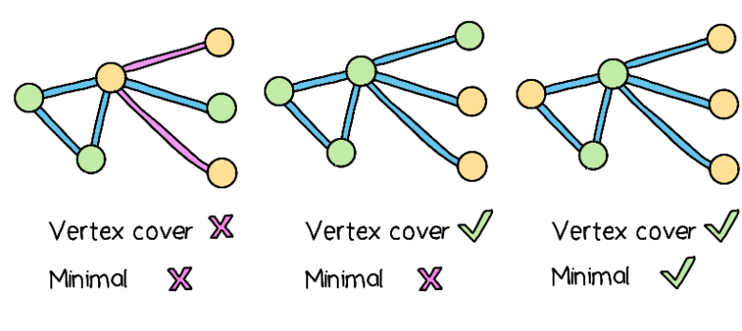

Task 1: Real-World Network Design
C++ Program
#include <iostream>
#include <list>
using namespace std;
class Graph
{
int V;
list<int> *adj;
public:
Graph(int V);
void addEdge(int v, int w);
void printVertexCover();
};
Graph::Graph(int V)
{
this->V = V;
adj = new list<int>[V];
}
void Graph::addEdge(int v, int w)
{
adj[v].push_back(w);
adj[w].push_back(v);
}
void Graph::printVertexCover()
{
bool visited[V];
for(int i=0;i<V;i++)
visited[i]=false;
for(int u=0;u<V;u++)
{
if(!visited[u])
{
for(auto v:adj[u])
{
if(!visited[v])
{
visited[u]=true;
visited[v]=true;
break;
}
}
}
}
cout<<"Vertices in Vertex Cover are:"<<endl;
for(int i=0;i<V;i++)
{
if(visited[i])
cout<<i<<" ";
}
cout<<endl;
}
int main()
{
Graph g(7);
g.addEdge(0,1);
g.addEdge(0,2);
g.addEdge(1,3);
g.addEdge(3,4);
g.addEdge(4,5);
g.addEdge(5,6);
cout<<"Task 1: Communication Network"<<endl;
g.printVertexCover();
return 0;
}

Expected Output
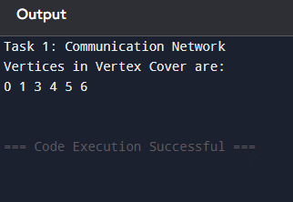
Task 1: Communication Network
Vertices in Vertex Cover are:
0 1 3 4 5 6
Explanation
- Vertices = Intersections
- Edges = Roads
- Selected vertices = Camera locations
- Every road is connected to at least one camera.

Task 2: Social Network Analysis
The same algorithm is used.
#include <iostream>
#include <list>
using namespace std;
class Graph
{
int V;
list<int> *adj;
public:
Graph(int V);
void addEdge(int v,int w);
void printVertexCover();
};
Graph::Graph(int V)
{
this->V=V;
adj=new list<int>[V];
}
void Graph::addEdge(int v,int w)
{
adj[v].push_back(w);
adj[w].push_back(v);
}
void Graph::printVertexCover()
{
bool visited[V];
for(int i=0;i<V;i++)
visited[i]=false;
for(int u=0;u<V;u++)
{
if(!visited[u])
{
for(auto v:adj[u])
{
if(!visited[v])
{
visited[u]=true;
visited[v]=true;
break;
}
}
}
}
cout<<"Selected Users:"<<endl;
for(int i=0;i<V;i++)
{
if(visited[i])
cout<<i<<" ";
}
cout<<endl;
}
int main()
{
Graph g(6);
g.addEdge(0,1);
g.addEdge(0,2);
g.addEdge(1,3);
g.addEdge(2,4);
g.addEdge(3,5);
cout<<"Task 2: Social Network"<<endl;
g.printVertexCover();
return 0;
}
Expected Output
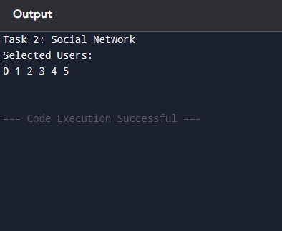
Task 2: Social Network
Selected Users:
0 1 2 3 4

Task 3: Resource Allocation
#include <iostream>
#include <list>
using namespace std;
class Graph
{
int V;
list<int> *adj;
public:
Graph(int V);
void addEdge(int v,int w);
void printVertexCover();
};
Graph::Graph(int V)
{
this->V=V;
adj=new list<int>[V];
}
void Graph::addEdge(int v,int w)
{
adj[v].push_back(w);
adj[w].push_back(v);
}
void Graph::printVertexCover()
{
bool visited[V];
for(int i=0;i<V;i++)
visited[i]=false;
for(int u=0;u<V;u++)
{
if(!visited[u])
{
for(auto v:adj[u])
{
if(!visited[v])
{
visited[u]=true;
visited[v]=true;
break;
}
}
}
}
cout<<"Machines Selected:"<<endl;
for(int i=0;i<V;i++)
{
if(visited[i])
cout<<i<<" ";
}
cout<<endl;
}
int main()
{
Graph g(6);
g.addEdge(0,1);
g.addEdge(0,2);
g.addEdge(1,4);
g.addEdge(2,3);
g.addEdge(3,5);
cout<<"Task 3: Resource Allocation"<<endl;
g.printVertexCover();
return 0;
}
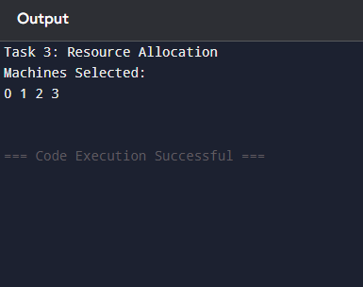

Task 4: Urban Planning
#include <iostream>
#include <list>
using namespace std;
class Graph
{
int V;
list<int> *adj;
public:
Graph(int V);
void addEdge(int v,int w);
void printVertexCover();
};
Graph::Graph(int V)
{
this->V=V;
adj=new list<int>[V];
}
void Graph::addEdge(int v,int w)
{
adj[v].push_back(w);
adj[w].push_back(v);
}
void Graph::printVertexCover()
{
bool visited[V];
for(int i=0;i<V;i++)
visited[i]=false;
for(int u=0;u<V;u++)
{
if(!visited[u])
{
for(auto v:adj[u])
{
if(!visited[v])
{
visited[u]=true;
visited[v]=true;
break;
}
}
}
}
cout<<"Park Locations:"<<endl;
for(int i=0;i<V;i++)
{
if(visited[i])
cout<<i<<" ";
}
cout<<endl;
}
int main()
{
Graph g(7);
g.addEdge(0,1);
g.addEdge(1,2);
g.addEdge(2,3);
g.addEdge(3,4);
g.addEdge(4,5);
g.addEdge(5,6);
cout<<"Task 4: Urban Planning"<<endl;
g.printVertexCover();
return 0;
}

Task 5: Game Development
#include <iostream>
#include <list>
using namespace std;
class Graph
{
int V;
list<int> *adj;
public:
Graph(int V);
void addEdge(int v,int w);
void printVertexCover();
};
Graph::Graph(int V)
{
this->V=V;
adj=new list<int>[V];
}
void Graph::addEdge(int v,int w)
{
adj[v].push_back(w);
adj[w].push_back(v);
}
void Graph::printVertexCover()
{
bool visited[V];
for(int i=0;i<V;i++)
visited[i]=false;
for(int u=0;u<V;u++)
{
if(!visited[u])
{
for(auto v:adj[u])
{
if(!visited[v])
{
visited[u]=true;
visited[v]=true;
break;
}
}
}
}
cout<<"Selected Players:"<<endl;
for(int i=0;i<V;i++)
{
if(visited[i])
cout<<i<<" ";
}
cout<<endl;
}
int main()
{
Graph g(6);
g.addEdge(0,1);
g.addEdge(0,2);
g.addEdge(1,3);
g.addEdge(2,4);
g.addEdge(4,5);
cout<<"Task 5: Game Development"<<endl;
g.printVertexCover();
return 0;
}
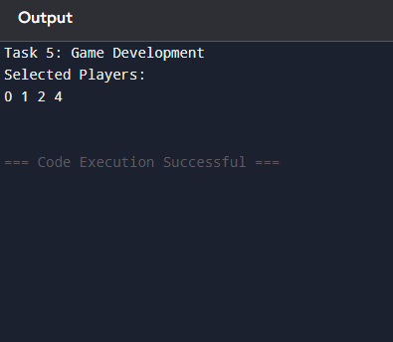

Vertex Cover Problem
6
5
1
7
4
2
3

1-> 2 [1]
2-> 1, 3, 5, 6, 7 [5]
3-> 2, 4, 7 [3]
4-> 3 [1]
5 -> 2 [1]
6-> 2, 7 [2]
7 -> 2, 3, 6 [3]
6
5
1
7
4
2
3

Solution Sub Set = {2}
3-> 4, 7 [2]
4-> 3 [1]
6 -> 7 [1]
7 -> 3, 6 [2]
Solution Sub Set = {2, 3}
6 -> 7 [1]
7 -> 6 [1]
Solution Sub Set = {2, 3, 6}

Algorithm
vertexCover()
{
Visited [v]
For (i =0 to V)
Visited[i] = false

For i=0 to V
If (visited [i] == false)
{
For i adj.begin to end()
Int v=v*i
If (visited [i] == false) {
Visited[v] = true
Visited[i] = true
End
}
}

